**UAV**

**UAVs** are a component of an **unmanned** aircraft system (**UAS**); which include a **UAV**, a ground-based controller, and a system of communications between the two.

The flight of **UAVs** may operate with various degrees of autonomy: either under remote control by a human operator or autonomously by onboard computers.

**Body**

The primary difference for planes is the absence of the cockpit area and its windows. Tailless quadcopters are a common form factor for rotary wing UAVs while tailed mono- and bi-copters are common for crewed platforms.

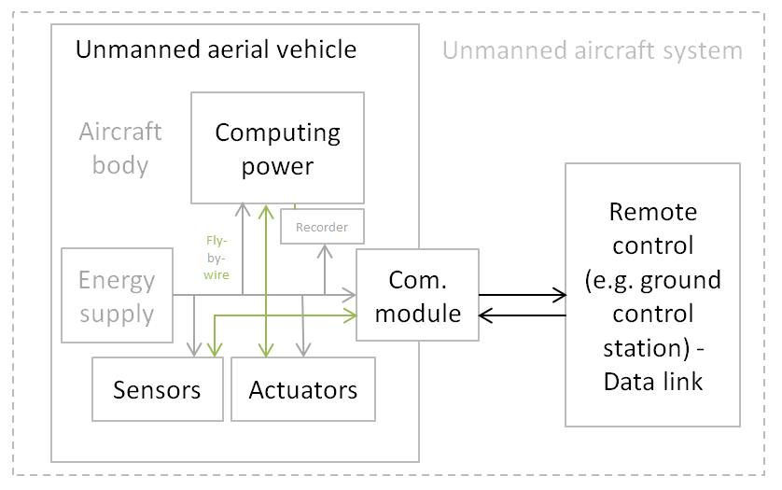

**Power supply and platforms**

Small UAVs mostly use [lithium-polymer batteries](https://en.wikipedia.org/wiki/Lithium_polymer_battery) (Li-Po), while larger vehicles rely on conventional airplane engines.

Scale or size of aircraft is not the defining or limiting characteristic of energy supply for a UAV. At present, the energy density of Li-Po is far less than gasoline.

The record of travel for a UAV (built from balsa wood and mylar skin) across the North Atlantic Ocean is held by a gasoline model airplane or UAV.

 Electric power is used as less work is required for a flight and electric motors are quieter. Also, properly designed, the thrust to weight ratio for an electric or gasoline motor driving a propeller can hover or climb vertically.

Botmite airplane is an example of an electric UAV which can climb vertically.

[Battery elimination circuitry](https://en.wikipedia.org/wiki/Battery_eliminator_circuit) (BEC) is used to centralize power distribution and often harbors a [microcontroller unit](https://en.wikipedia.org/wiki/Microcontroller) (MCU). Costlier switching BECs diminish heating on the platform.

**Computing**

UAV computing capability followed the advances of computing technology, beginning with analog controls and evolving into microcontrollers, then [system-on-a-chip](https://en.wikipedia.org/wiki/System_on_a_chip) (SOC) and [single-board computers](https://en.wikipedia.org/wiki/Single-board_computer) (SBC).

System hardware for small UAVs is often called the flight controller (FC), flight controller board (FCB) or autopilot.

**Sensors**

Position and movement sensors give information about the aircraft state. Exteroceptive sensors deal with external information like distance measurements, while exproprioceptive ones correlate internal and external states.

Non-cooperative sensors are able to detect targets autonomously so they are used for separation assurance and collision avoidance.

**Actuators**

UAV [actuators](https://en.wikipedia.org/wiki/Actuator) include [digital electronic speed controllers](https://en.wikipedia.org/wiki/Electronic_speed_control) (which control the [RPM](https://en.wikipedia.org/wiki/Revolutions_per_minute) of the motors) linked to motors/[engines](https://en.wikipedia.org/wiki/Engine) and [propellers](https://en.wikipedia.org/wiki/Propeller), [servomotors](https://en.wikipedia.org/wiki/Servomotor) (for planes and helicopters mostly), weapons, payload actuators, LEDs and speakers.

**Communications**

Most UAVs use a [radio](https://en.wikipedia.org/wiki/Radio) for remote control and [exchange of video and other data](https://en.wikipedia.org/wiki/Data_link). Early UAVs had only [narrowband](https://en.wikipedia.org/wiki/Narrowband) uplink.

The bi-directional narrowband radio links carried command and control (C&C) and [telemetry](https://en.wikipedia.org/wiki/Telemetry) data about the status of aircraft systems to the remote operator.

For very long range flights, military UAVs also use [satellite](https://en.wikipedia.org/wiki/Satellite) receivers as part of [satellite navigation](https://en.wikipedia.org/wiki/Satellite_navigation) systems.

In cases when video transmission was required, the UAVs will implement a separate analog video radio link.

In the most modern UAV applications, video transmission is required. So instead of having 2 separate links for C&C, telemetry and video traffic, a [broadband](https://en.wikipedia.org/wiki/Broadband) link is used to carry all types of data on a single radio link.

These broadband links can leverage [quality of service](https://en.wikipedia.org/wiki/Quality_of_service) techniques to optimize the C&C traffic for low latency. Usually these broadband links carry [TCP/IP](https://en.wikipedia.org/wiki/TCP/IP) traffic that can be routed over the Internet.

The radio signal from the operator side can be issued from either:

* Ground control – a human operating a [radio transmitter](https://en.wikipedia.org/wiki/Transmitter)/receiver, a smartphone, a tablet, a computer, or the original meaning of a [military ground control station (GCS)](https://en.wikipedia.org/wiki/Ground_control_station). Recently control from [wearable devices](https://en.wikipedia.org/wiki/Wearable_technology), human movement recognition, [human brain waves](https://en.wikipedia.org/wiki/Electroencephalography) was also demonstrated.
* Remote network system, such as satellite duplex data links for some [military powers](https://en.wikipedia.org/wiki/Armed_forces).
* Downstream digital video over mobile networks has also entered consumer markets, while direct UAV control uplink over the cellular mesh and LTE have been demonstrated and are in trials.
* Another aircraft, serving as a relay or mobile control station – military manned-unmanned teaming (MUM-T).
* A protocol [MAVLink](https://en.wikipedia.org/wiki/MAVLink" \o "MAVLink) is increasingly becoming popular to carry command and control data between the ground control and the vehicle

**Basic principles**

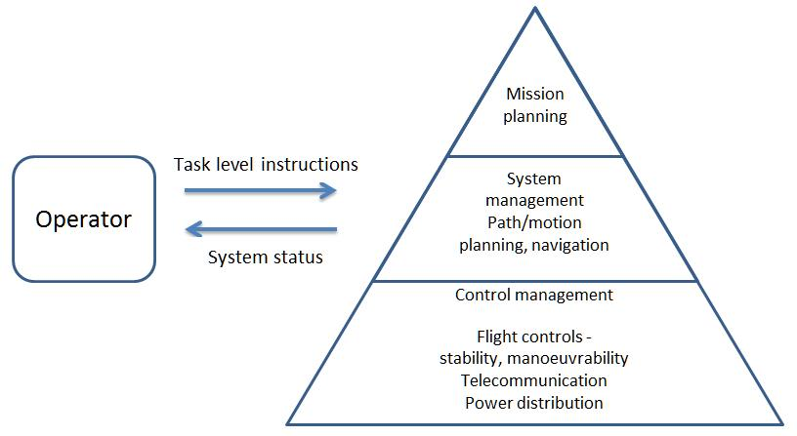

One way to achieve autonomous control employs multiple control-loop layers, as in [hierarchical control systems](https://en.wikipedia.org/wiki/Hierarchical_control_system).

The principle is to decompose the aircraft's behavior into manageable "chunks", or states, with known transitions.

Hierarchical control system types range from simple [scripts](https://en.wikipedia.org/wiki/Scripting_language) to [finite state machines](https://en.wikipedia.org/wiki/Finite-state_machine), [behavior trees](https://en.wikipedia.org/wiki/Behavior_tree) and [hierarchical task planners](https://en.wikipedia.org/wiki/Hierarchical_task_network).